Welcome to Daisy Direct

Contents
Introduction 2
Hardware description 3
Using Daisy Direct for the first time 7
Starting up 7
Copying books 8
Reading books 10
Copying magazines 12
Reading magazines 14
Power management 15
Support 16
Troubleshooting 17

Introduction
Daisy Direct is a system developed by the Blind Foundation for delivering audio books and magazines direct to you for use with your DAISY player.
It runs on a dedicated device, to download books from the Blind Foundation Library collection, according to the reading preferences you have selected as a Library member. You can download up to 100 books each month from Daisy Direct. You can also receive the latest issues of magazines, selected from the current titles produced by the Foundation.
The device has special USB drives attached, which are used to copy books and magazines from the device, so you can read them on your DAISY player.
When you receive Daisy Direct, the package should contain the following: a cardboard box containing the device, with 2 USB drives attached by nylon lanyards; the charger for recharging the battery; an audio instruction CD; and a large print copy of these instructions. Braille instructions are also available on request. Please retain the packaging, in case you need to return your Daisy Direct to the Blind Foundation for any reason.

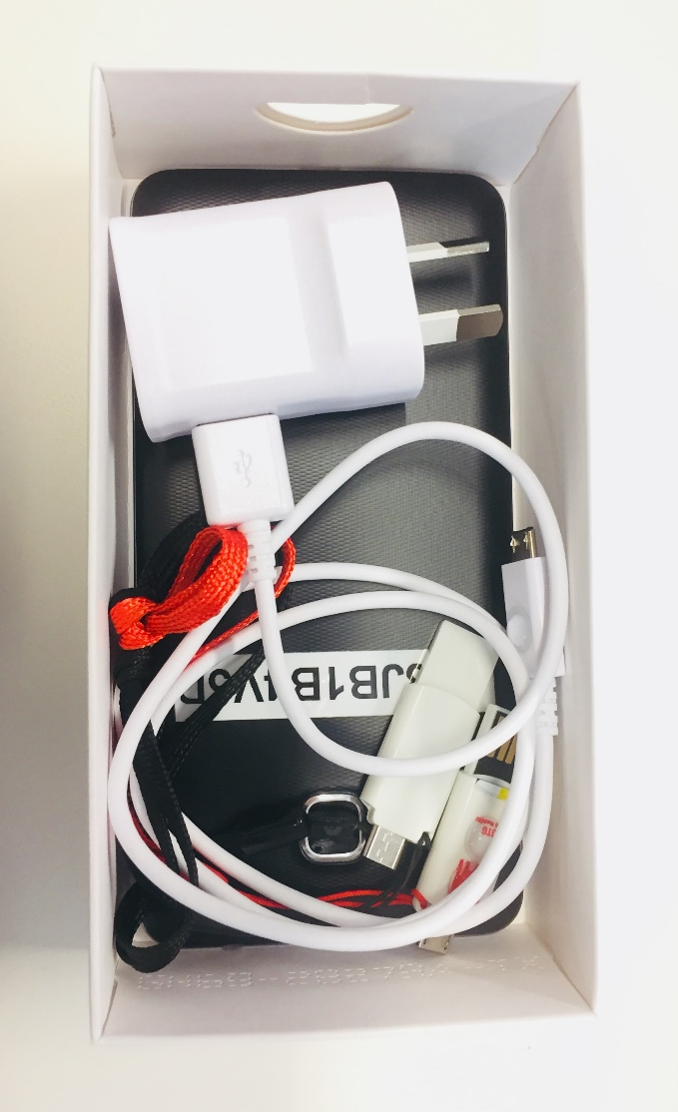
Figure 1: Daisy Direct equipment in box

Hardware description

Device
Daisy Direct is a thin, flat device about 7 by 14 centimetres across. It has a glass screen on one side which usually faces up or towards you. It relies on you listening and responding to automated voice instructions, so you don’t have to use the screen. There is a lanyard attached to the back of the device, so the device may not sit flat on your table.
To familiarise yourself with the device, place it on a flat surface in front of you with the case side down, and the rectangular shaped button on the screen side closest to you. This rectangular button is not used for Daisy Direct, but you can use it to work out which way up the device is. You will feel a long button on the left edge of the device, and a shorter button on the right edge.
Power button
USB drive
Volume button
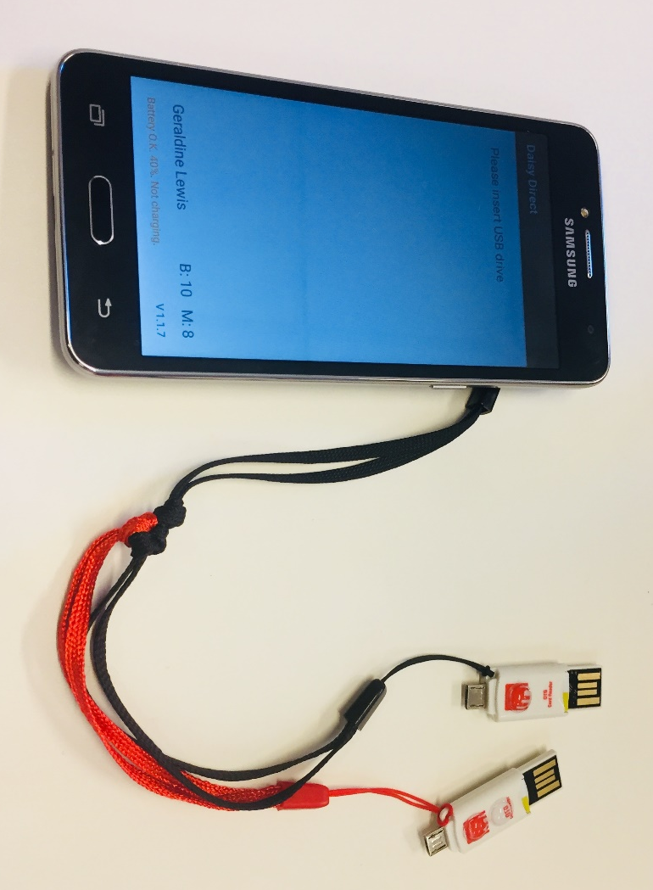
Charging socket
Lanyard
Figure 2: Front view of Daisy Direct

Power button
The small button on the right edge of the device is the power button. A long press on this button will turn Daisy Direct on or off. A short press on this button enables the mute function when the device is on. A second short press will un-mute the device, and give a general status report.

Volume button
You can control the volume of the announcements in Daisy Direct with the volume button on the left edge of the device. This button is about twice the length of the power button. You can press the top half of this button to increase the volume of the announcements, or the bottom half of the button to decrease the volume.

Charging socket
The charging socket is at the bottom edge of the device, in the centre, directly beneath the rectangular button. To make this easier to find, there is a raised dot on the back of the device, lined up with the charging socket. This is also where you attach the USB drive when copying books or magazines.

USB drives
There are 2 USB drives attached to your Daisy Direct, one for receiving books, and the other for magazines. Each USB drive is a small plastic device about 4 centimetres long, with two connectors, one at either end. The small, narrow metal connector is used to connect the drive to Daisy Direct for copying audio files. The wider, plastic connector is for plugging the drive into your DAISY player for reading. There are raised dots on one side of each USB drive, to help you tell which way up it is when connecting to Daisy Direct or your DAISY player. The USB drive for books has one dot, and the drive for magazines has two dots, to help you tell them apart.

Charger
The charger is used to recharge the device battery from your mains power supply. One end has a standard two-pin plug, which plugs into an ordinary power socket. The charger cable is about 1.5 metres long, and the other end has a small metal connector, which attaches to the charging socket on the bottom edge of Daisy Direct. There is a small raised dot on the bottom of the charger connector, so that you can line it up with the dot on the back of Daisy Direct. It is possible to remove the charger cable from its plug, but please leave it connected, to ensure you can always charge your Daisy Direct.
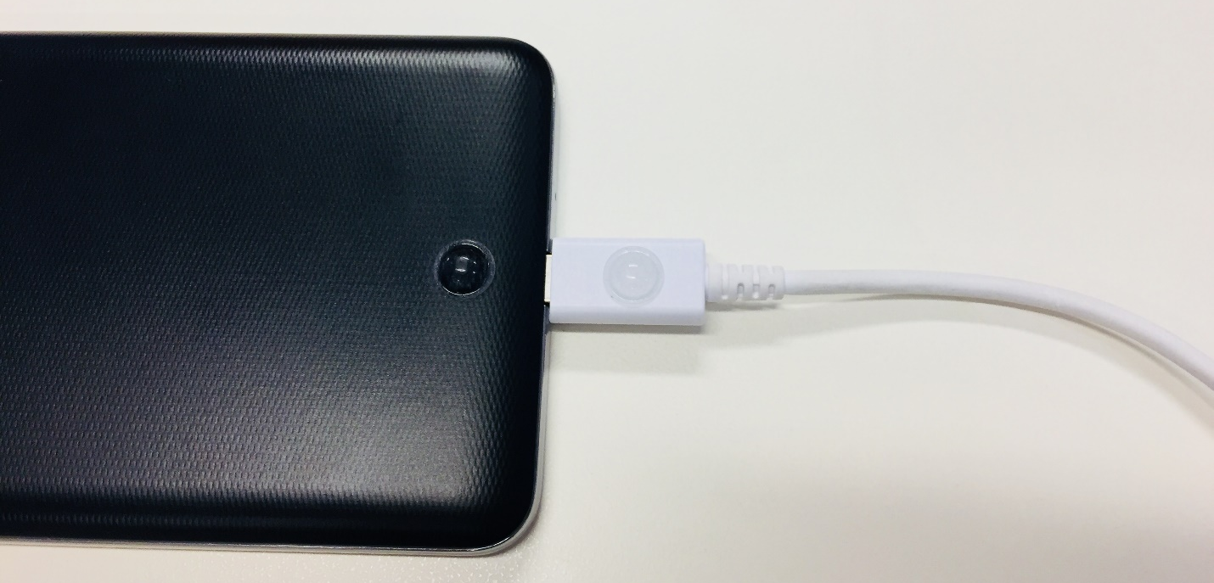
Figure 3: Back view of charger plugged into Daisy Direct, showing raised dots aligned

Using Daisy Direct for the first time
Before using Daisy Direct for the first time, you will need to charge the battery for a minimum of one hour. Plug the small connector on the charger into the charging socket on the bottom edge of Daisy Direct. Make sure the raised dots on the back of the device and on the connector are aligned.
While the battery is charging, you can also read any books already on the USB drive, with your DAISY player. Your first 3 books will already be copied to the USB drive when you receive your Daisy Direct (see “Reading Books”, page 10).

Starting up
- Press and hold the power button to turn on Daisy Direct.
- The device will either awake from mute mode, or vibrate slightly and begin starting up.
- If there is no response, the device may require charging. For more detail, please read the section called “Power management” later in this document.
- If the device vibrates, wait for approximately one minute while Daisy Direct starts up.
- If you hear the message, “Battery OK”, then Daisy Direct is ready for use.

Copying books
- When the device is ready, you should hear the message, "Please insert USB drive." This means there are books ready for copying to your USB drive for reading.
- If Daisy Direct is charging, remove the charger before proceeding.
- Insert the small connector of the book USB drive into the Daisy Direct charging socket until it feels secure. This is the small metal connector on the USB drive near where the lanyard attaches. There is a single raised dot on the USB drive which lines up with the dot on the back of Daisy Direct.
- You will hear the message, "USB drive plugged in", followed by "Checking profile."
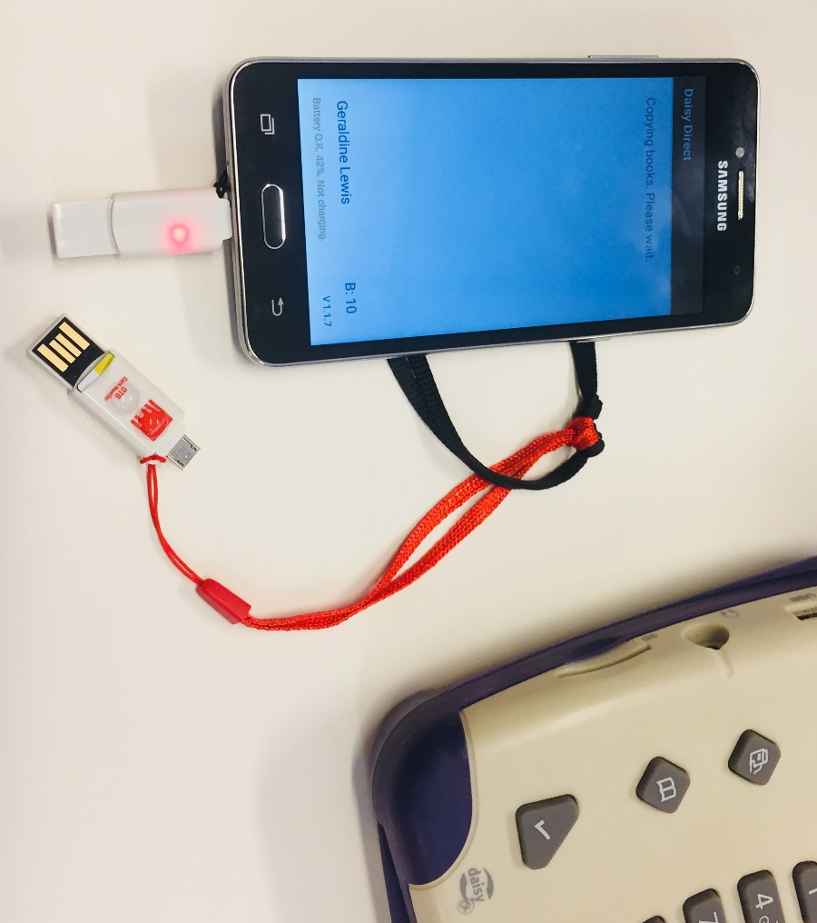
Figure 4: Daisy Direct with USB drive plugged into charging socket

- Daisy Direct will remove any books already on the USB drive before copying any new books. Please note that you can only have 3 books on the USB drive at one time, and these books will be removed each time you plug the USB drive into Daisy Direct.
- While books are being copied to the USB drive, you will hear the message "Copying books. Please wait." This message will repeat until your next 3 books have been copied.
- You will then hear the message, "3 Daisy books are ready on the USB drive. You may unplug the USB drive from the device and plug it into the Daisy player for listening."
- Remove the USB drive from Daisy Direct.
- You will hear the message, "USB drive unplugged."
- Press the power button on Daisy Direct to mute announcements until you are ready to get more books.

Reading books
- Power on your DAISY player, if it is not already on.
- Hold the book USB drive with the raised dot facing upwards.
- Insert the USB connector into the USB port, which is the rectangular port located at the rear left side of your DAISY player. This is behind the round hole for headphones. It will take a few seconds to read the drive, before announcing some information about the first book title.

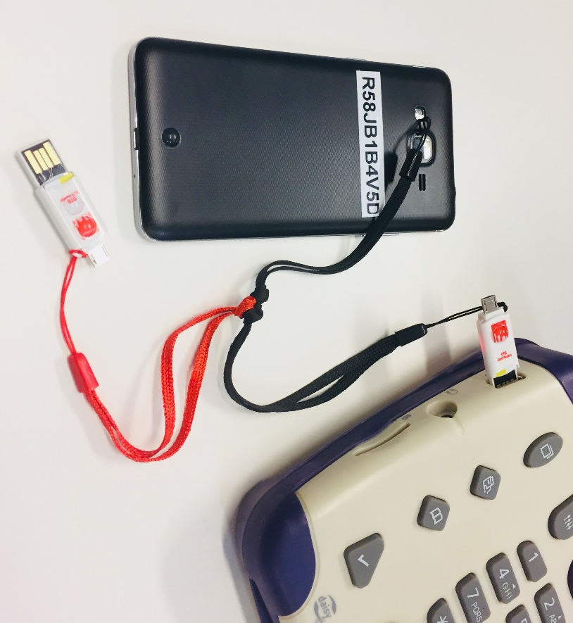
Figure 5: USB drive plugged into USB port of DAISY player for reading

- A tone will sound when all the information has been read. You should receive 3 books in each batch copied to the USB drive from Daisy Direct.
- To move between DAISY books stored on the USB drive, use the triangular arrow keys at the front of the player to the right of the play controls.
- You can either read the books from the USB drive, or copy the books you want to read to your DAISY player’s own memory. This lets you build up a selection of books to read later, without having the USB drive plugged into your player. For help using your DAISY player in advanced mode, please contact the Library on 0800 24 33 33.
- Press the wide, rectangular Play button on the front of the DAISY player to start or stop reading a book.
- When you are ready to read your next batch of books, or if you want to check your magazines, remove the USB drive from the player. Remember that the books on it will be deleted from the USB drive when you plug it back into Daisy Direct.
- You will hear the confirmation message, "The USB drive has been removed.”
- Return to the section, "Copying books", to receive your next 3 books from Daisy Direct.

Copying magazines
- If Daisy Direct is charging, remove the charger before proceeding.
- Insert the small connector of the magazine USB drive into the Daisy Direct charging socket until it feels secure. This is the small metal connector on the USB drive near where the lanyard attaches. There are two raised dots on the USB drive which line up with the dot on the back of Daisy Direct.
- You will hear the message, "USB drive plugged in", followed by "Checking profile."
- Daisy Direct will then check for new magazine issues which have been produced since you last updated your magazines. If there are no new issues available, you will hear the message, “There are no magazines to update. Please try again later.”
- If there are new issues of your subscribed magazines available, you will hear the message, "Copying magazines. Please wait." This message will repeat until all of your magazines have been updated.
- Daisy Direct will then tell you how many new issues have been copied, for example, "4 Daisy magazines have been updated to the USB drive. You may unplug the USB drive from the device and plug it into the Daisy player for listening."
- Remove the USB drive from Daisy Direct.
- You will hear the message, "USB drive unplugged."
- Press the power button on Daisy Direct to mute announcements until you are ready to get more magazines or books.

Reading magazines
- Power on your DAISY player, if it is not already on.
- Hold the magazine USB drive with the two raised dots facing upwards.
- Insert the USB connector into the USB port, which is the rectangular port located at the rear left side of your DAISY player. This is behind the round hole for headphones. It will take a few seconds to read the drive, before announcing some information about the first magazine issue on the drive.
- To move between your magazines on the USB drive, use the triangular arrow keys at the front of the player to the right of the play controls.
- Each magazine in your subscriptions will be announced with its title and date of publication. The magazines will always be in the same order, so you will have to cycle through them to find the latest updates.
- Press the wide, rectangular Play button on the front of the DAISY player to start or stop reading a magazine.
- When you are finished reading magazines, remove the USB drive from the player.
- You will hear the confirmation message, "The USB drive has been removed.”

Power management
Daisy Direct will tell you about its battery status while you're using it. If it has less than 15% charge, it will detect the battery is getting low, and ask you to charge it. To check the battery status, press the power button on the right edge of the device.
- Press the button and release it to hear the message, "Muted".
- Press it again to wake the device, and hear the battery status.
- You will hear either, "Battery OK. Not charging", or, “Battery low. Please connect to charger”, along with the percentage of current battery life remaining.
- This status report also tells you how many books and magazines have been downloaded and are ready for copying. It also provides a counter of how many books you have received that month, up to a limit of 50 books.
When you need to charge Daisy Direct, plug the small connector on the charger into the charging socket on the bottom edge of Daisy Direct. Make sure the raised dots on the back of the device and on the connector are aligned. When connected, you will hear the message, "Battery OK. Charging."
You may want to keep the charger and Daisy Direct equipment near your DAISY player, so that everything you need is in the same space.
You can also turn Daisy Direct off when you are not using it, to save battery power. Hold the power button on the right edge of the device to hear the message, "Power off".
If you have not used your Daisy Direct in some time, you can start it on mains power to check the battery level. Plug the charger in first, before starting up Daisy Direct. Even if the battery level is very low, the device should start up correctly while connected to the charger. You can then check the available battery life by pressing the power button twice for the status message.

Support
For assistance with using your Daisy Direct, or to update your profile selections, please contact the Library team on the Blind Foundation free phone number, 0800 24 33 33. As well as randomly selected books, we can deliver specific titles to you by Daisy Direct, so if you would like to request particular works (such as favourite authors, or new books promoted in the Library newsletters), please contact the Library team.

Troubleshooting

“Downloading. Please wait.”
If you hear the message, "Downloading. Please wait", while you have the USB drive plugged into Daisy Direct, it means there are not yet enough books ready to copy to your USB. If you are waiting to get new books to read, you can leave the USB plugged in, and Daisy Direct will automatically copy your next 3 books when they are ready. Otherwise, you can remove the USB drive, and Daisy Direct will continue to download books.

"Battery low. Please connect to charger."
If you hear this while using Daisy Direct, it means the battery is getting low and needs to be recharged. Remove the USB drive from Daisy Direct if it is still attached, and plug in the charger to charge the battery.

"A connection error has occurred.”
If you hear the message, "A connection error has occurred. Please make sure your device has a good network coverage. The app will try again in a minute", this means there has been a problem with the network connection to the Blind Foundation. Daisy Direct should recover from this within about 10 minutes.

"Downloading has been stopped due to unexpected errors.”
Daisy Direct will keep trying to download books, to make sure there are books stored on the device ready for reading. If it has problems, you may hear the message, "Downloading has been stopped due to unexpected errors. It will resume next time you plug in the USB drive." When you next plug the USB drive into the device to copy books, the download process will start again.

"Downloading has been stopped, as you have received 100 books this month.”
There is a limit to the number of books you can download with Daisy Direct each month, which is currently set at 100. This is because the audio book files can be quite large, and it is necessary to manage the amount of data used for Daisy Direct across all of our readers. If you reach your limit for the month, book downloads will be suspended, and you will be able to start receiving books again from the beginning of the following month. Updates to your magazine subscriptions are not affected.

"There is not enough space left on the device.”
Daisy Direct stores copies of all of your current magazines, and will download as many books as it can, so that there will be some ready to copy when you want to read new books. If you are subscribing to a lot of magazine titles, this may reduce the number of books Daisy Direct can store in advance. You should still be able to receive new books, so this message is just letting you know that it cannot hold the usual maximum of 10 books.

"There are no more books available that match your reading profile.”
If you are a very fast reader, or have chosen very specific preferences for your reading profile, you may run out of suitable audio books in the Library collection. You may then hear the message, "There are no more books available that match your reading profile. Please call 0800 24 33 33 to request more books. Downloading will resume next time you plug in the USB drive." Please call the Library on 0800 24 33 33 to check your current profile, or request more books to be added to your queue.

"There are no magazines to update. Please make sure your magazine subscription has been set up correctly.”
You may hear this message when you plug the magazine USB drive into Daisy Direct, if you have not previously subscribed to any of our magazine titles. If you would like to receive audio magazines from Daisy Direct, or to find out which magazines are available, please call the Library on 0800 24 33 33.

Daisy Direct doesn’t recognise the USB drive.
If Daisy Direct doesn’t respond when you plug in the USB drive, please check that the USB connector is firmly inserted all the way into the Daisy Direct charging socket.

My DAISY player doesn’t recognise the USB drive.
When you plug the USB drive into your DAISY player, the raised dot should be facing upwards. It is possible to insert the USB drive upside down. If it is inserted upside down, the player will not recognise the USB drive.

“Read error -2204. Unable to play content.”
If you hear this message from your DAISY player when you try to open a book on the USB drive, it means that part of the book has not downloaded correctly from the Library collection. Each book contains many small files for the audio and structure information, and if any are damaged, the book will not read on your DAISY player. The player can still tell you the title of the book, so if you would like us to send you that book again, please contact the Library on 0800 24 33 33.

